Press Release – Week 1

Clermont Show – The Isaac Region’s Show

***Clermont Show Introduces New Junior Competitions***

The Clermont Show Committee is very excited to introduce more junior competitions to this year’s *Clermont Show – The Isaac Region’s Show*. A Junior Rural Ambassador and Mini Rural Ambassador will be new categories to the 2016 Rural Ambassador competition, while a Mini Miss Showgirl will be sashed in the 2016 Isaac Region Miss Showgirl Competition.

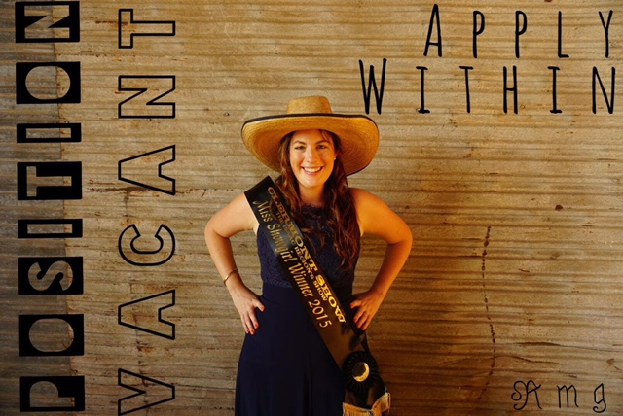The Junior Rural Ambassador category is open to both male and female entrants and has an age bracket of 15-20 years for eligibility, while the Mini categories in both the Rural Ambassador and Miss Showgirl competitions invite children (young boys or girls) in primary school grades 3 to 6 to enter and become involved.

2015 Miss Showgirl, April Roth said, “I encourage youth from the whole Isaac Region to participate in the competitions.

“I wanted to introduce the new categories in these competitions to enable youth in the area to become more involved in the Show. I enjoyed participating in the Miss Showgirl competition as I was able to get involved more within the Clermont Community and meet new people.”

2015 Rural Ambassador Jake Kennedy, who represented the Central Highlands Show region at the State Finals in Brisbane at the Ekka last August, said that he “gained confidence and leadership skills from participating in the competition.”

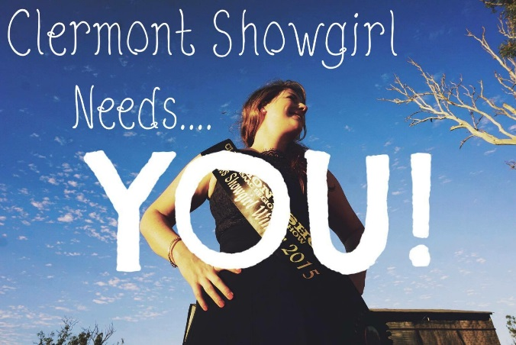The interviews and judging for Senior and Junior & Mini Miss Showgirls and Rural Ambassadors will take place on Saturday 23rd April 2016, at the Heritage Building, Clermont Showgrounds.

Announcement of winners and presentations will be that night, at Clermont Show’s first Woolshed Ball.

We wonder what will happen in the Woolshed…

For more information or a nomination form, please contact April Roth 0400 223 346.